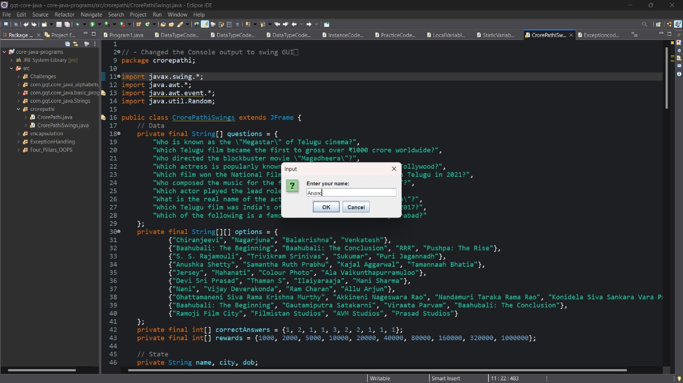TFI Quiz Game using Swings

Fig 1: Taking Username as input

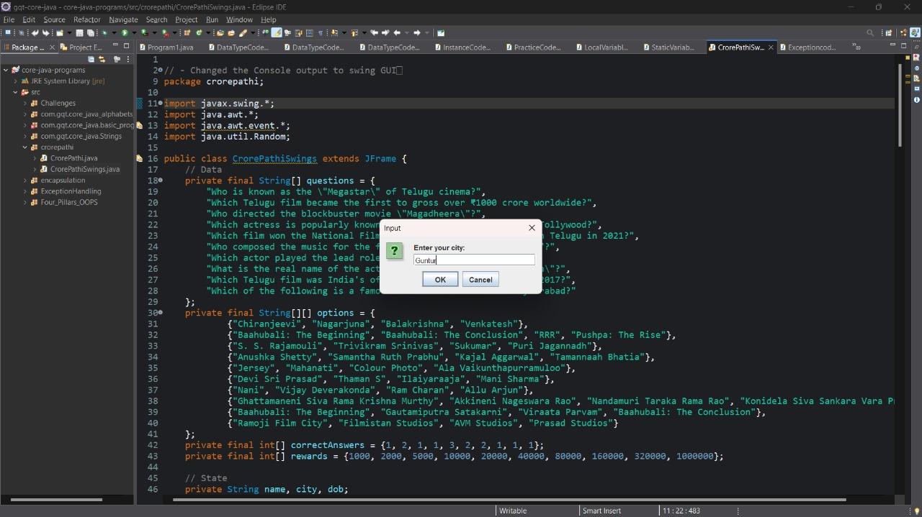

Fig 2: Taking User city as input

Fig 3: Taking User date of birth as input

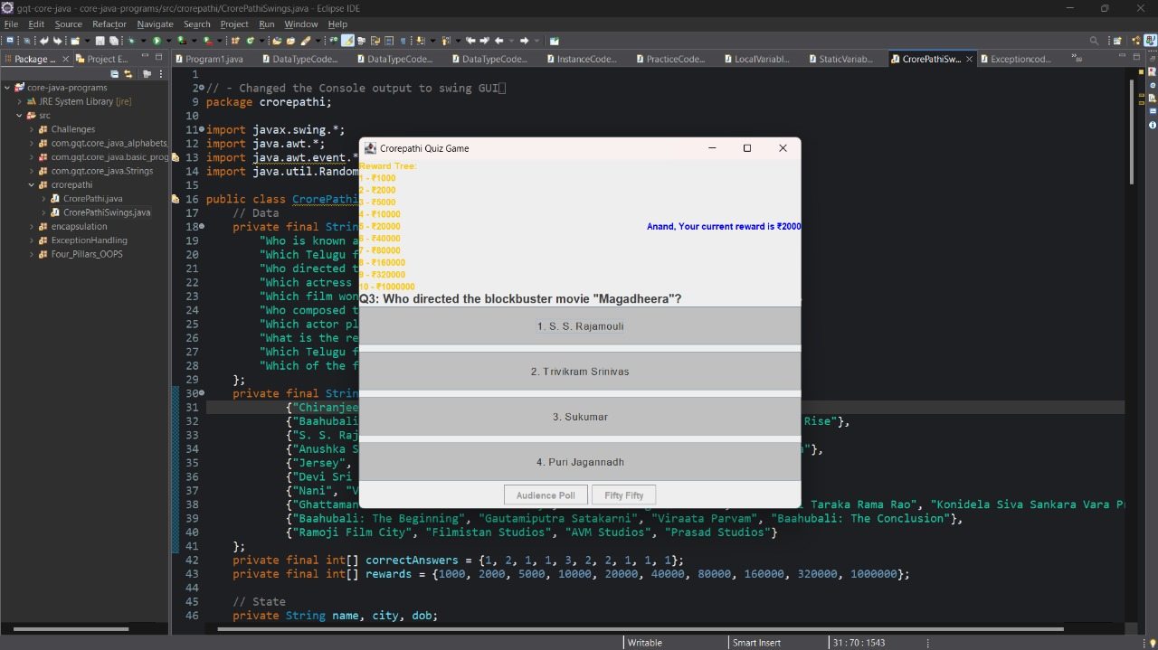

Fig 4: Game starts after taking all the inputs

Fig 5: Dialogue box will appear if the chosen answer is wrong

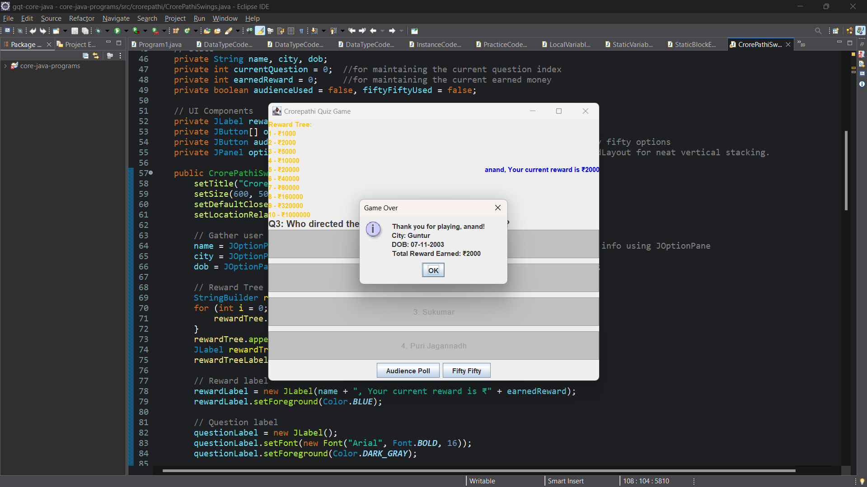

Fig 6: Dialogue box will appear with the user details with earned prize money